**TOTAL JOINT EXERCISES**

Please do these exercises 10 times each, for 3 sets. Make sure to rest between sets. Try to do an exercise session in the morning, afternoon, and evening.

***Exercises in bed or on the floor:***

**Ankle Pumps (calf muscles)**

1. Lie on your back
2. Flex foot to knee
3. Then point your toes away from you
4. Move continuously 10 times

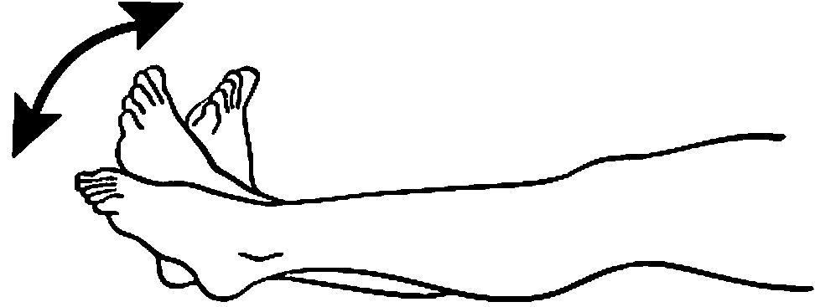

**Quad Sets**

1. Lie on your back
2. With your leg extended, flex toes toward your nose
3. Tighten your thigh muscles and butt muscles at the same time
4. Keep leg and butt flat on the floor
5. Hold for 10 seconds each

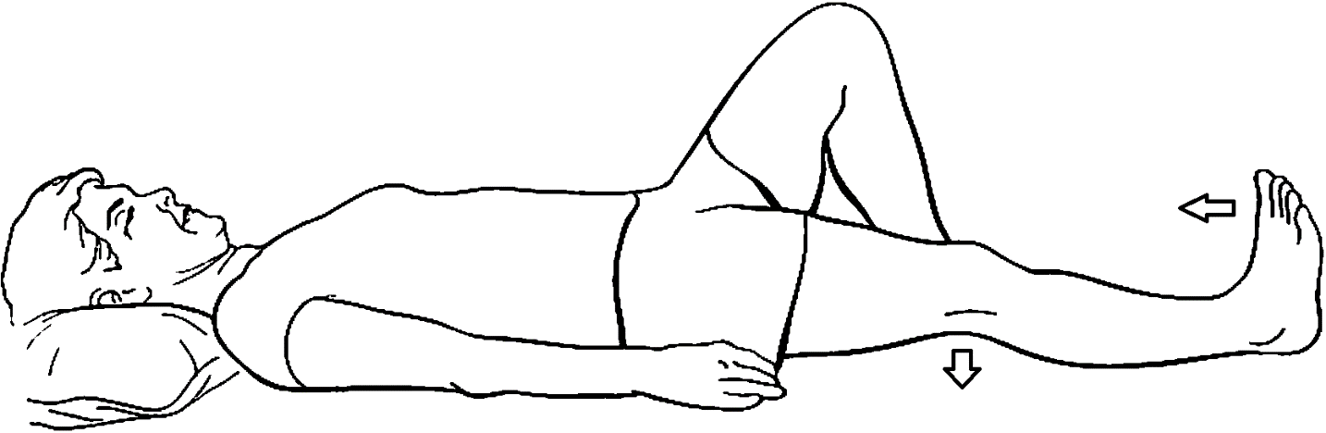

**Heel Slide**

1. Lie on your back
2. Slide your heel towards your butt – until you feel a gentle stretch
3. Keep your heel on the floor
4. Hold for 10 seconds each

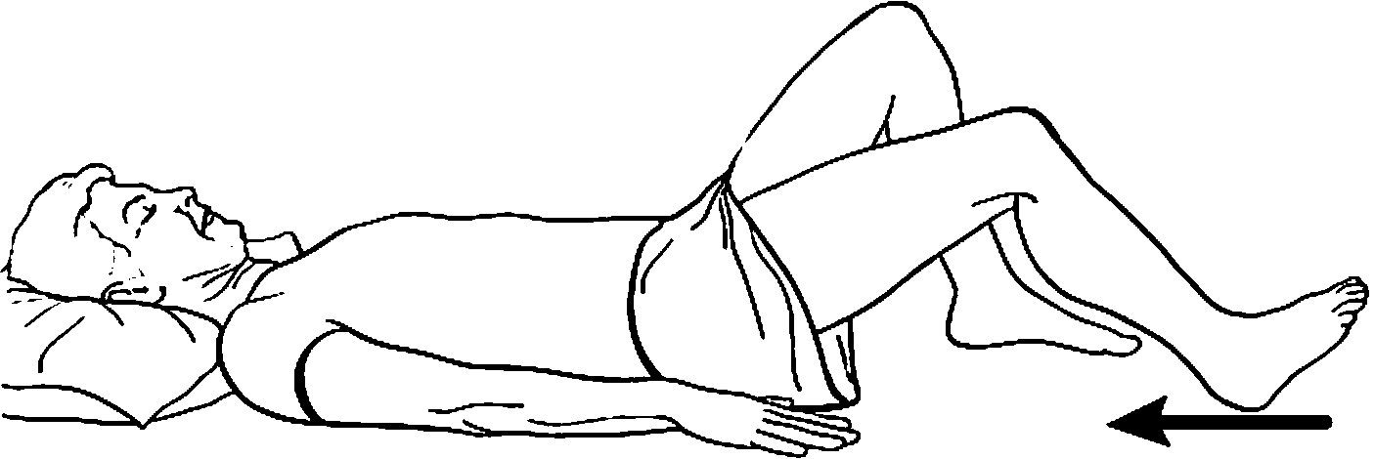

**Hip Abduction**

1. Lie on your back
2. Keep the leg you are exercising straight.
3. Bend opposite leg to decrease strain on the lower back
4. Slide the leg you are exercising out to side and back.

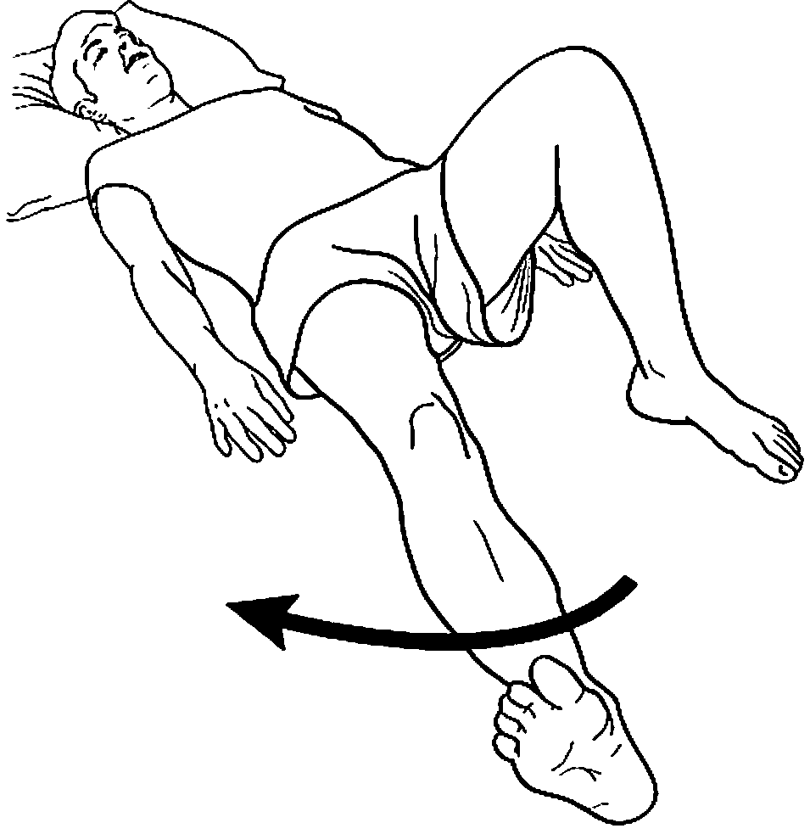

**Knee Extension**

1. Lie on your back
2. Place knee you are exercising over rolled pillow
3. Bend opposite leg to decrease strain on the lower back
4. Straighten knee by tightening muscles on top of thigh
5. Keep bottom of knee on pillow

***Note: Do NOT keep pillow under your knees after your exercise.***

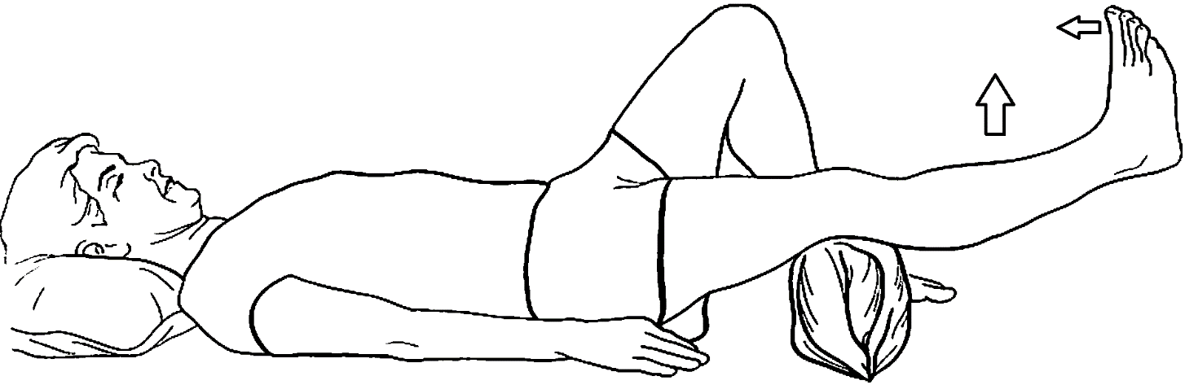

**Sitting Exercises**

**Heel Raise**

1. While sitting in a chair move the heel of your leg up and down
2. Hold up for 2 seconds each

**Toe Raise**

1. While sitting in a chair move your toes of your foot up and down
2. Hold up for 2 seconds each

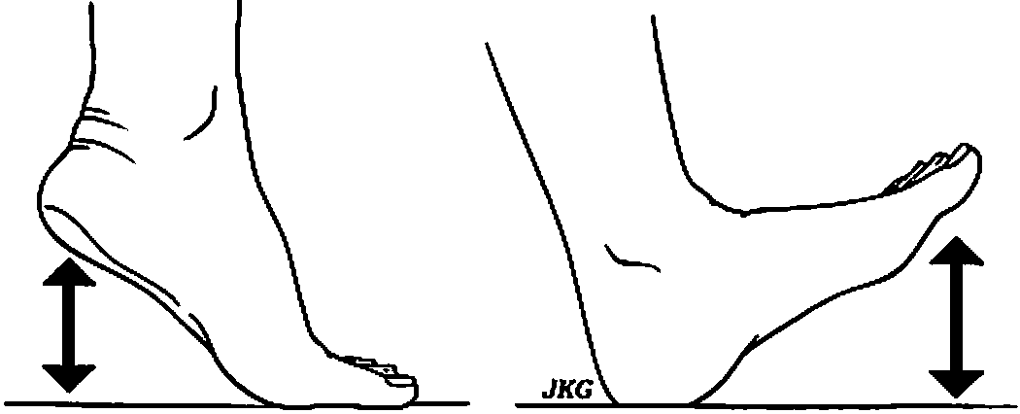

**Knee Extension**

1. While sitting on a chair, extend your operated leg out and back
2. Hold for 10 seconds each

