[Example “In the News” item](https://www.mountsinai.org/about/newsroom/2021/implant-may-improve-lives-of-those-with-serious-balance-disorder):

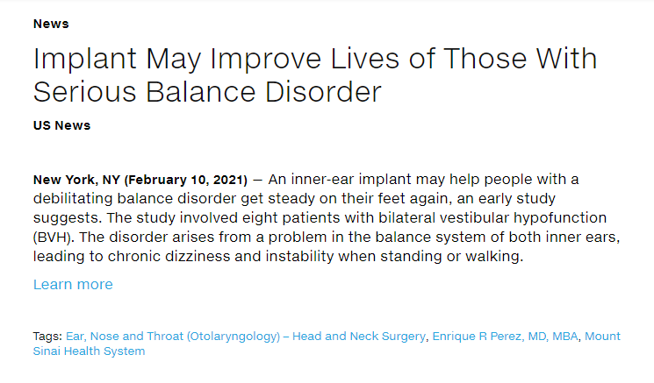

|  |
| --- |
| *Please follow this format to submit “In the News” items to be added to the* [*Mount Sinai Newsroom*](https://www.mountsinai.org/about/newsroom)  *Please send completed forms to* [*webfeedback@mountsinai.org*](mailto:webfeedback@mountsinai.org)  *\* denotes required field* |

|  |  |
| --- | --- |
| **Title**\* |  |
| **Location** |  |
| **Display Date**\* |  |
| **Media Source**\* |  |
| **Short summary**\*  *(1-4 sentences)* |  |
| **Learn more hyperlink**\*  *(this is the link to the news site)* |  |
| **Tags**\*  *(at least one service line, institute, center, lab, program, person)* |  |

|  |  |
| --- | --- |
| **Title**\* |  |
| **Location** |  |
| **Display Date**\* |  |
| **Media Source**\* |  |
| **Short summary**\*  *(1-4 sentences)* |  |
| **Learn more hyperlink**\* |  |
| **Tags**\*  *(at least one service line, institute, center, lab, program, person)* |  |

|  |  |
| --- | --- |
| **Title**\* |  |
| **Location** |  |
| **Display Date**\* |  |
| **Media Source**\* |  |
| **Short summary**\*  *(1-4 sentences)* |  |
| **Learn more hyperlink**\* |  |
| **Tags**\*  *(at least one service line, institute, center, lab, program, person)* |  |

|  |  |
| --- | --- |
| **Title**\* |  |
| **Location** |  |
| **Display Date**\* |  |
| **Media Source**\* |  |
| **Short summary**\*  *(1-4 sentences)* |  |
| **Learn more hyperlink**\*  *(this is the link to the news site)* |  |
| **Tags**\*  *(at least one service line, institute, center, lab, program, person)* |  |

|  |  |
| --- | --- |
| **Title**\* |  |
| **Location** |  |
| **Display Date**\* |  |
| **Media Source**\* |  |
| **Short summary**\*  *(1-4 sentences)* |  |
| **Learn more hyperlink**\* |  |
| **Tags**\*  *(at least one service line, institute, center, lab, program, person)* |  |

|  |  |
| --- | --- |
| **Title**\* |  |
| **Location** |  |
| **Display Date**\* |  |
| **Media Source**\* |  |
| **Short summary**\*  *(1-4 sentences)* |  |
| **Learn more hyperlink**\* |  |
| **Tags**\*  *(at least one service line, institute, center, lab, program, person)* |  |

|  |  |
| --- | --- |
| **Title**\* |  |
| **Location** |  |
| **Display Date**\* |  |
| **Media Source**\* |  |
| **Short summary**\*  *(1-4 sentences)* |  |
| **Learn more hyperlink**\*  *(this is the link to the news site)* |  |
| **Tags**\*  *(at least one service line, institute, center, lab, program, person)* |  |

|  |  |
| --- | --- |
| **Title**\* |  |
| **Location** |  |
| **Display Date**\* |  |
| **Media Source**\* |  |
| **Short summary**\*  *(1-4 sentences)* |  |
| **Learn more hyperlink**\* |  |
| **Tags**\*  *(at least one service line, institute, center, lab, program, person)* |  |
| **Title**\* |  |
| **Location** |  |
| **Display Date**\* |  |
| **Media Source**\* |  |
| **Short summary**\*  *(1-4 sentences)* |  |
| **Learn more hyperlink**\* |  |
| **Tags**\*  *(at least one service line, institute, center, lab, program, person)* |  |

|  |  |
| --- | --- |
| **Title**\* |  |
| **Location** |  |
| **Display Date**\* |  |
| **Media Source**\* |  |
| **Short summary**\*  *(1-4 sentences)* |  |
| **Learn more hyperlink**\* |  |
| **Tags**\*  *(at least one service line, institute, center, lab, program, person)* |  |

|  |  |
| --- | --- |
| **Title**\* |  |
| **Location** |  |
| **Display Date**\* |  |
| **Media Source**\* |  |
| **Short summary**\*  *(1-4 sentences)* |  |
| **Learn more hyperlink**\*  *(this is the link to the news site)* |  |
| **Tags**\*  *(at least one service line, institute, center, lab, program, person)* |  |

|  |  |
| --- | --- |
| **Title**\* |  |
| **Location** |  |
| **Display Date**\* |  |
| **Media Source**\* |  |
| **Short summary**\*  *(1-4 sentences)* |  |
| **Learn more hyperlink**\* |  |
| **Tags**\*  *(at least one service line, institute, center, lab, program, person)* |  |

|  |  |
| --- | --- |
| **Title**\* |  |
| **Location** |  |
| **Display Date**\* |  |
| **Media Source**\* |  |
| **Short summary**\*  *(1-4 sentences)* |  |
| **Learn more hyperlink**\* |  |
| **Tags**\*  *(at least one service line, institute, center, lab, program, person)* |  |

*(copy and paste table to add additional entries)*